13.102: Let 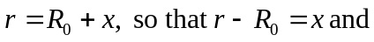
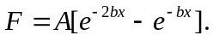
When x is small compared to 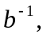 expanding the exponential function gives
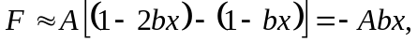

corresponding to a force constant of 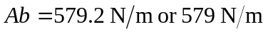 to three figures. This is close to the value given in Exercise 13.40.

